Task 1

- Locate a file name index.html in html/ltr folder.
- Open index.html file in any code editor.
- Examine the sidebar existing code carefully.
- Add 5 new hyperlinks as follows on index.html. You may refer to attached image as your guideline.
  - Menu ALL
  - Menu HEA
  - Menu HEP
  - Student
    - New Student (HEA ONLY)
    - List of Student (BOTH)
- Save the index.html to index.php

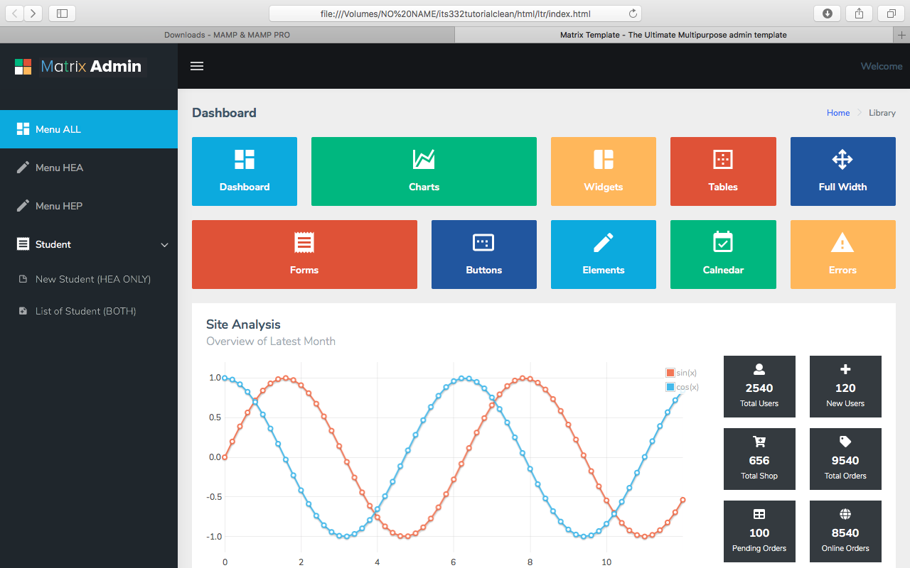

Task 2

- Locate a file name form-basic.html in html/ltr folder.
- Study how the html form is constructed using html5 scripting.
- Using the form-basic.html file, you need to create 5 html form elements as follows. However, you need to remove all unnecessary form elements in the file. Please refer to attached image below.
- The 5 form elements are:
  - A student number textfield
  - A student name textfield
  - A student email textfield
  - A dropdown list that will populate list of programs from database
  - A submit button

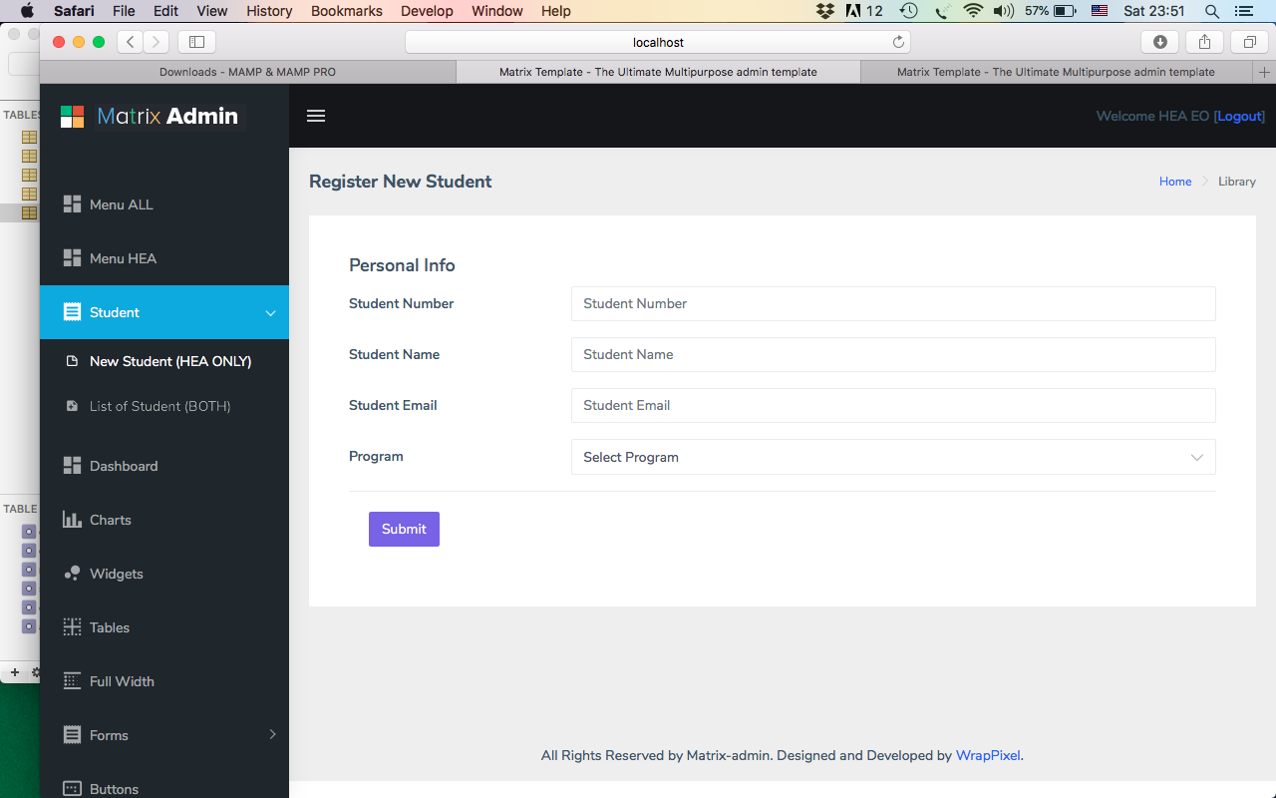

- Save the file as newstudent.php

